**IMPLEMENTATION OF AUTONOMOUS ROBOT FOR ANALYSIS OF ENVIRONMENTAL STRESS AND PLANT PHENOTYPIC RESPONSES IN WARMING CHAMBER AND/OR GREENHOUSE SETUP**

An Undergraduate Research Scholars Thesis

by

DARIO AVENDANO

Submitted to the Undergraduate Research Scholars program at

Texas A&M University

in partial fulfillment of the requirements for the designation as an

UNDERGRADUATE RESEARCH SCHOLAR

Approved by Research Advisor: Dr. Xiaoning Qian

May 2018

Major: Electrical Engineering

TABLE OF CONTENTS

Page

ABSTRACT 1

Dedication 2

Acknowledgments 3

Nomenclature 4

chapter

1. IntroductioN 5

Background 5

Scope 5

1. METHODS 7

Introduction 7

Experiment 7

Design and Equipment 8

1. Results 16

Key Findings 16

Image Analysis 16

CPS 26

1. CONCLUSION 28

references 29

appendix 31

Abstract

Implementation of Autonomous Robot for Analysis of Environmental Stress and Plant Phenotypic Responses in Warming Chamber and/or Greenhouse Setup

Dario Avendano

Department of Electrical Engineering

Texas A&M University

Research Advisor: Dr. Xiaoning Qian

Department of Electrical Engineering

Texas A&M University

Thermal imaging of plants allows for the assessment of plants’ response to heat and water deprivation. A cyber-physical system(CPS) that can collect, monitor, and deliver Infrared (IR) and Visible Light(VL) images can help for the monitoring of experiments in a greenhouse setup. Due to the layout of a greenhouse, it is important for the system to be compact and mobile. The system also has to be controllable through a network interface in order to allow remote control and it has to be able to deliver data through the network. That is why the system will be implemented using a Raspberry Pi in conjunction with ROS.

Furthermore, once the monitoring pictures have been delivered, analysis of the responses will be done using Python in conjunction with the image analysis library OpenCV.

What we hope to achieve is to show the proof-of-concept of such a CPS with the preliminary results showing a clear difference between responses of plants that have been watered and plants that have not reflected in measurement changes in both IR and VL images. These results will also allow to possibly recognize patterns in plants response and thus leading to the development of a prediction model. With such a CPS of both data collection and analysis modules, future experiments will be able to be monitored remotely and effectively.

Dedication

I dedicate this paper to my family. To my parents, for the opportunities they provided for me and their unconditional love. To my grandmother, who growing up taught me to believe in myself. To my siblings for their support and their guidance. To my nephews and niece for reminding me of the simple aspects of life. Finally, to my girlfriend for not only supporting me throughout college but for believing me even at the moments where my confidence faltered.

I would also like to dedicate this paper to Dr. Qian that beyond being my advisor, provided me with a vote of confidence at a very critical moment this year.

Acknowledgements

I would like to thank my Faculty Advisor, Dr. Qian, and my Faculty Co-Advisor, Dr. Hur, for all their guidance and support throughout the course of this project. I am very humbled to have shared this year with them as my advisors.

I would also like to thank the department of Electrical Engineering and Computer Science faculty for providing me with background knowledge and problem-solving skills that I was able to implement in the project.

I want to extend my gratitude to the URS program. Their hard work and structured schedule allowed me to succeed and it can’t be understated that they provide students with a very rewarding experience.

Finally, I would like to thank all my family and friends that have given me their support through my college experience.

Nomenclature

IR Infra-Red

VL Visible Light

CPS Cyber Physical System

ROS Robot Operating System

Chapter i

introduction

Background

Potatoes receive around 22-in rainfall during growing season. Most of the water comes from irrigation. The cost of water is around 175US$ per acre. Given that there is around 20,000 acres of land planted (2016), the price for irrigation translates to about 3.5 mill US$. The amount of water used is attributed to the fact that potatoes thrive in a well-drained and loose soil. Given that Texas weather conditions can greatly affect the stress responses towards drought related problems, it is of the utmost importance to find an effective way to not only monitor the growth of the potatoes but to model the response to different levels of irrigation.

**Scope**

A cyber-physical system (CPS) that integrates sensors, robots and data analytics will allow for the dynamic monitoring of warming chambers and greenhouses. With such a system, plant researchers can be provided with information to better design experiments, effectively monitor and control the environments, and receive data that can allow real-time decision making.

A customized drone can obtain data at different resolution levels that can improve the monitoring of the different characteristics of the plants. More specifically, the infrared (IR) and visible light (VL) image analysis, can help leaf detection and tracking, 3D modeling, motion analysis, and heat response monitoring that reflects the plant’s tolerance towards different water and heat stresses.

Furthermore, active data collection can allow for swift intervention from researchers, and thus can shorten the experimental time and variable costs, such as problems related to drought stress, or amount of water needed for the growth of the different varieties of potatoes.

Chapter ii

methods

**Introduction**

As stated, the Agri-Robot must be able to dynamically monitor plants in a greenhouse environment and provide remote-access to the researchers to allow for real-time decision making. There are specific tasks that the robot has to be able to accomplish. Given that a drone provides a lot of flexibility in terms of movement, it was chosen as the medium to carry the visible light and infrared cameras.

As far as a controller, the Pi-Zero is the best choice as it is a very compact device that allows for a Wi-Fi connection and also for the implementation of a smaller drone. This can be a very useful trait, as it allows for more maneuverability.

In terms of an operating system, Raspberry Pi’s are run through a Linux-based distribution. For this project, Raspbian was chosen due to the amount of support it has and the ability to incorporate ROS for the controlling of the drone.

**Experiment**

The main action in the experiment was that of taking the pictures that would be later analyzed and compared. This action changed throughout the year. At the beginning, pictures were only taken with the visible light camera daily with the plant being watered every week. This specific setup turned out to be not effective. From day to day, there were barely any differences between the pictures, and the plant seemed to be unaffected when watered every week.

For the second setup, Pictures were taken once a week (one side-view picture every time) and the plant was watered every 1.5 or 2 weeks. This was proven to dry the plant to a point where there were noticeable differences in the pictures.

Finally, once the IR camera was implemented, the method of watering the plant remained unchanged, but more pictures were taken at each time point with both side-view and top-view pictures by both the VL and IR cameras, giving a total of 4 pictures every time point.

**Design and Equipment**

There were different factors that had to be considered for the design of the drone.

Mobility, integration, and adaptability were among some of the factors that in the end impacted decisions of the design of the system.

*CPU*

For the CPU, the Raspberry Pi was chosen. It is a low-cost device, that enables the user to perform basic tasks that are available in a computer, such as browsing the internet. For this specific experiment, the Raspberry Pi allows us to have freedom in the mobility system of the CPS, and to have access to tools needed for analysis, such as python and OpenCV, and to tools needed for controlling the drone, such as ROS.

*ROS*

The next important factor to consider was the integration with ROS. ROS is robotics middleware that provides freedom when choosing the components for the robot as it is very efficient with resource handling and communication between processes. It can be used with C++ and Python, and due to its growing community, it has support for many different useful tools. When considering integration with ROS, there were some problems that arise. Initially, due to its compact size in comparison to the other designs, the Raspberry Pi Zero model was chosen over the Raspberry Pi Two and Three. Given that mobility is an important factor, the compact size of the Zero model is probably the only feasible option when it comes to incorporating the robot on a drone. However, this means that the processor is smaller and its architecture is different. The Zero model runs ARMv6, while the Two runs ARMv7 and Three model runs Cortex-A53, the latter being newer versions. Due to this specific attribute, Ubuntu MATE, the operating system version that best supports ROS, cannot be installed on a Raspberry Pi Zero. Nevertheless, ROS indeed can be used in conjunction with a Raspberry Pi Zero, but the process of installing it is complicated. It must be installed from source for Operating Systems based on Debian (Linux-based Operating system) such as Jessie, the OS chosen for the Robot.

*Installation*

The installation followed was the one found at [1]. This was an arduous process. Initially, Raspbian Stretch was installed as the OS. The process for installing ROS in this distribution failed after many tries, due to some of the packages not being able to compile. The reason why said packages did not compile is inconclusive. Given that Stretch is the latest Raspbian distribution, there are probably some limitations when it comes to support for some of the tools needed for source ROS installation. On other hand, Raspbian Jessie provided a more descriptive guide for installation and even though it took several tries to install ROS, in the end it worked.

*Mobility*

Two options where considered when choosing the mobility of the robot the Turtle Burger and a drone.

The Turtle Burger allows for a two-dimensional maneuvering and provides stability and control when choosing when to stop or move the robot. It is easily integrated with the Raspberry Pi. Nevertheless, it is hard to implement effectively throughout a greenhouse and it does not provide as much maneuverability as the other design due to its two-dimensional movement.

*Picture Taking*

Figure 1 shows one example of the side-view VL images of the plant under study. Once the IR camera was implemented in the design the pictures taken at each instance were two VL pictures and two IR pictures, one with the top view and another one with the side view as seen in Figure 3. The VL pictures were taken with the Camera Module V2.1 included in the Raspberry Kit. The IR picture were taken with the Lepton Module V1.4.

Pictures were also taken at different brightness levels to determine which color space could be used for the analysis to diminish the effect of brightness. (Figure 2).

Also, to provide a solution to the possible automatization of the process, a color marker was placed in the plant. Once the pixel value of said marker was captured by the video feed of the camera, it would take both the IR and VL picture from the side. (Figure 4).

Also, to provide a solution to the possible automatization of the process, a color marker was placed in the plant. Once the pixel value of said marker was captured by the video feed of the camera, it would take both the IR and VL picture from the side. (Figure 4).

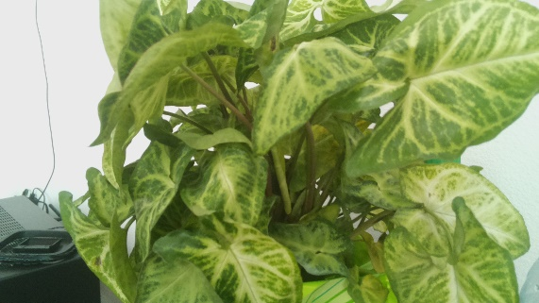 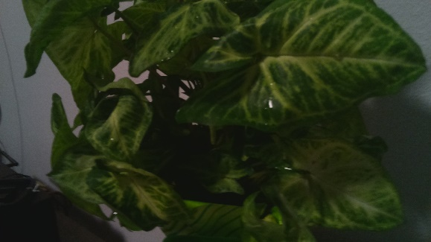

Figure 1. Initial Picture Figure 2. Picture with lower brightness

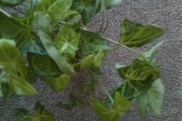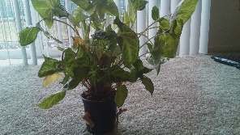 aaaaaaaaa (a) (b) (c) (d)

Figure 3. (a) VL Top view (b) VL Sideview (c) IR Sideview (d) IR Top view

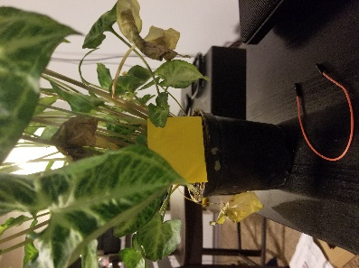

Figure 4. Physical marker for automation of picture taking action

*Image Analysis:*

All of the image analysis was done through OpenCV library in Python. OpenCV is a programming library designed to provide support for computer vision applications and machine learning[2]. In this experiment, OpenCV was used mainly to create and develop tools that could provide useful information from the pictures, such as pixel value of areas of the picture, transformations, and implementation of filters.

Initially density plots of pixel values were adopted to show the difference from picture to picture. A common used tool in the OpenCV library called graph-cut was utilized to crop the area of interest and analyze it. The result can be seen in Figure 5. This approach proved not to be enough to establish differences between pictures so other paths were taken.

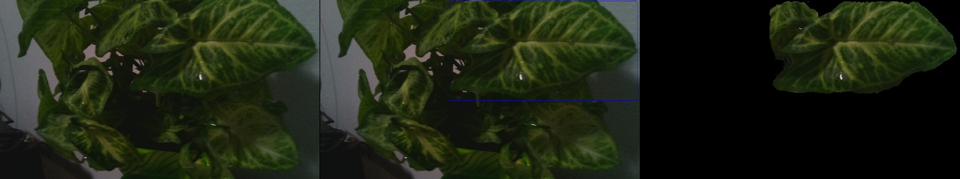

(a)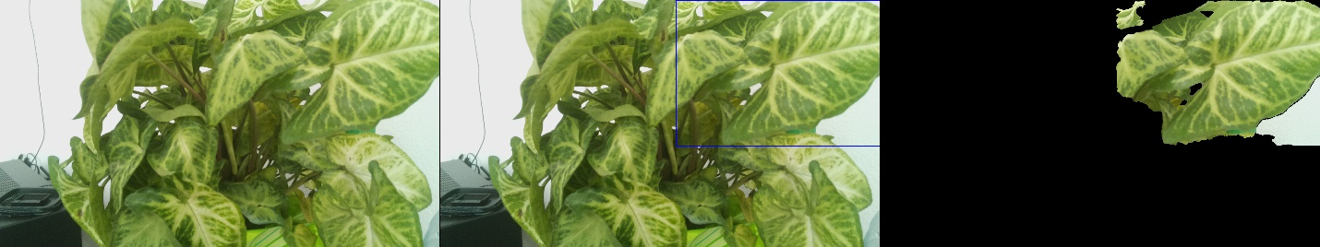

(b)

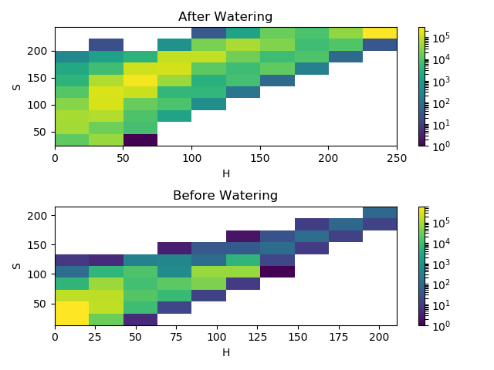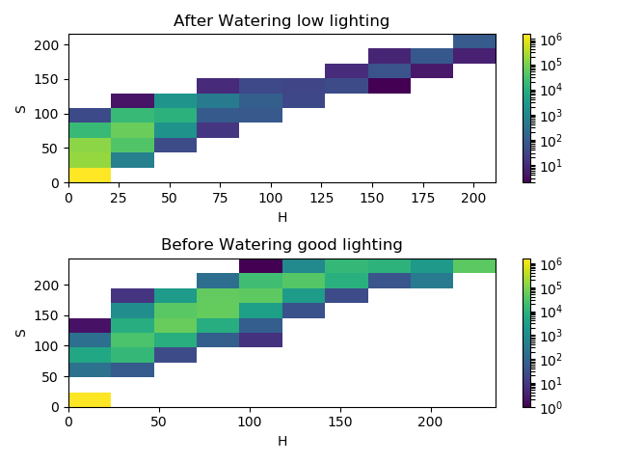

(c)

Figure 5. (a), (b) Examples of VL images(c) Example of density plots

The second approach involved using an interactive tool where the user can gauge the range of the components of a color space (in the case of this example HSV color space) needed for the segmentation of the areas of interest in the picture. Once the segmentation is determined, the contours are drawn in the picture and analysis can be done on them. This approach was not further pursued because it is not straightforward, and the data can become very skewed when the contour areas are small. An example of this approach can be seen in Figure 6.

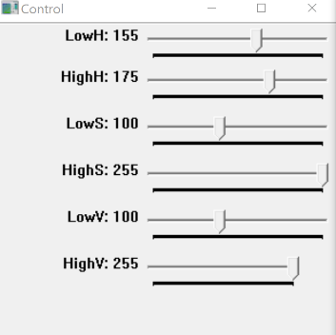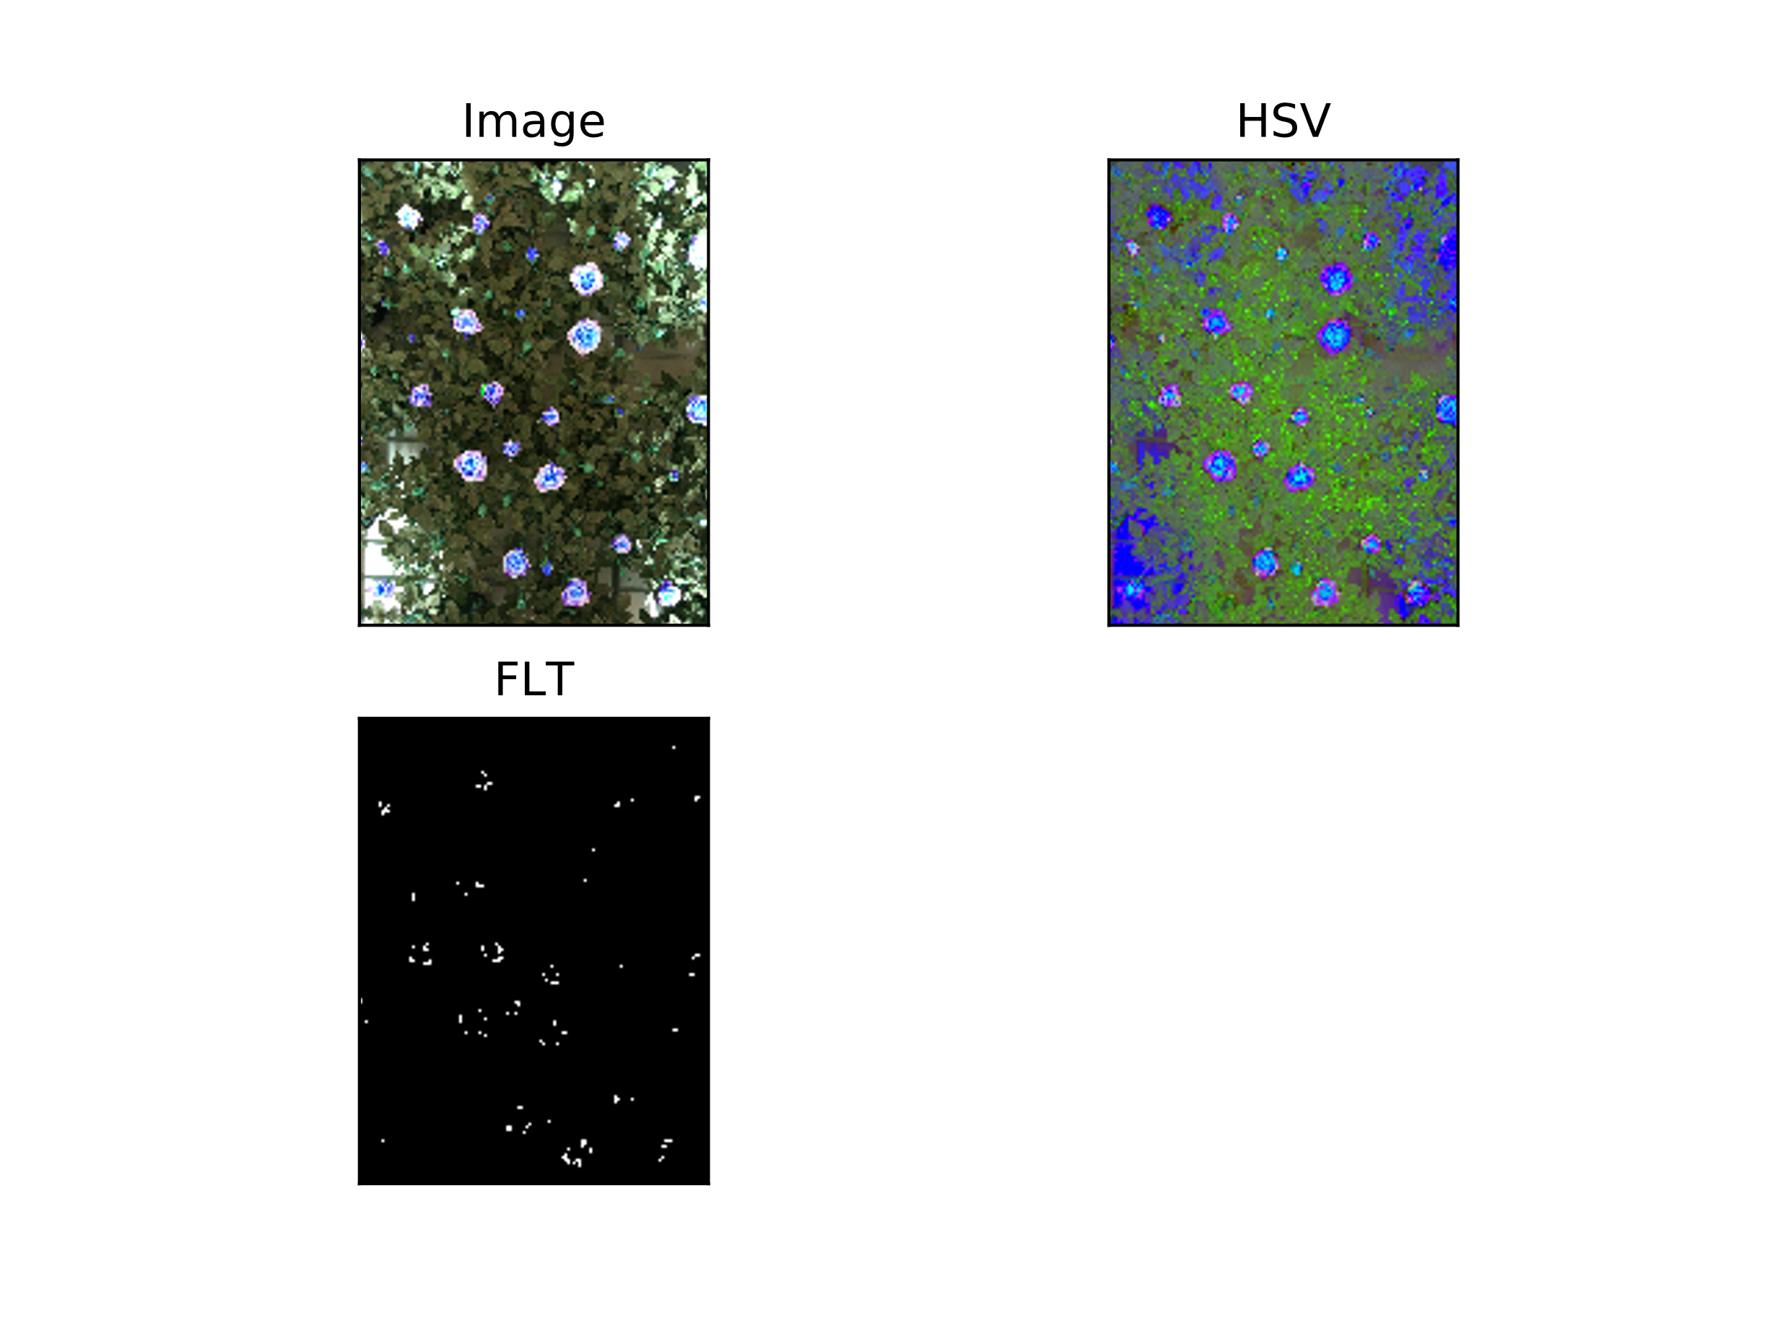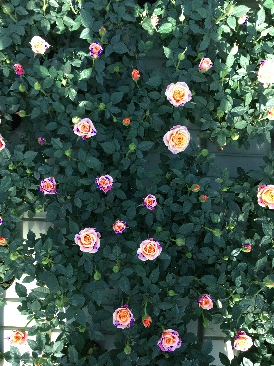

1. (b) (c)

Figure 6: (a) UI used to find intended segmentation given by components value (b) Changes in segmentation given by the movements in (a). (c) Intended Segmentation drawn on the original image.

The approach taken at the end to do the analysis involved the user selecting 5 points on an image that would create a polygon of the area of interest. Average component values and standard deviation are then calculated on the area given by the polygon. The process can be seen in Figure 7.

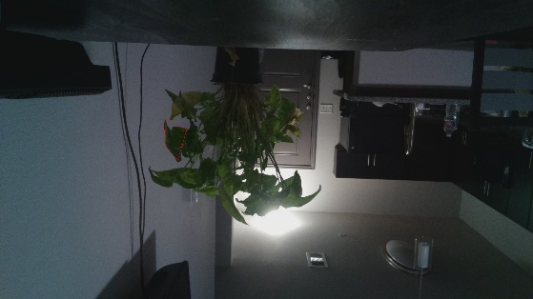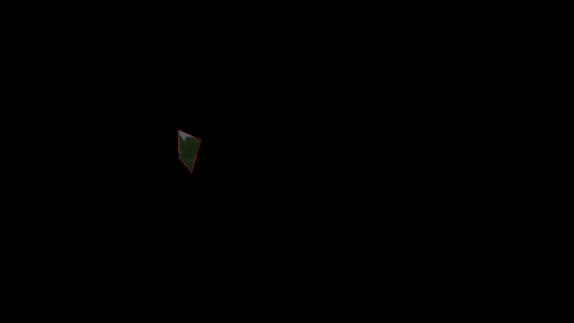

1. (b)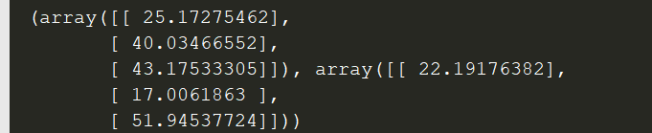

(c)

Figure 7. (a) Polygon selected on the image denoted by red lines (b) Cropped Area of interest (c) Output of average value of components followed by standard deviation of components. (HSV color space used for this example).

Chapter III

Results

**Key Findings**

Analysis of the images provide the proof-of-concept of three basic ideas. The first one being that by utilizing the HSV color space, the effect of the brightness of the environment can be diminished. Second, thermal analysis of IR pictures provides proof of differences between plants that were watered and plants that are not. And third, pixel analysis on landmarked areas in a VL picture provide proof of difference between responses of plants to drought stress.

On the other hand, in relation to the development of the CPS, the results show that it is possible to develop a device that can deliver the pictures remotely and that can autonomously take pictures given some variables in the environment.

**Image Analysis**

*HSV Color space*

Four Color spaces were considered when trying to determine which one would be the most adequate for image analysis, HSV, LAB, YCrCb, and BGR. To understand how to make an adequate decision it is important to highlight how each space is defined. Representation of each color space can be seen in Figure 8.

BGR is the same as RGB, except that Blue occupies the most significant area and Red occupies the least significant area. That being said , BGR is an additive space where Blue, Red , and Green colors can be combined in proportions to obtain any color in the visible spectrum[3].

YCrCb represents colors as the luma/brightness (Y) component and two difference-chroma components Cr and Cb, where Cr is the red-difference component and Cb is the blue-difference component. Both chroma channels are the representation of the channel in relation to the luma (Y) component of a picture. In order to attain color value, both channels are combined.[4].

LAB works similarly to YCrCb in the sense that luminance is represented by L and it has two other color channels (A and B). This model was designed to approximate human vision through the manipulation of the L component. Red/green components are expressed by the A channel and blue/yellow components are expressed in the B channel. Color value is given by the linear combination of both[5].

In the HSV color space, pure color values are expressed through the Hue component. The Saturation value provides information about the approximation to an absolute white color and Value provides information about the approximation to an absolute black color of the Hue value. A combination of the Saturation and Value components provide “tints” and “shades” of the Hue value respectively[6].

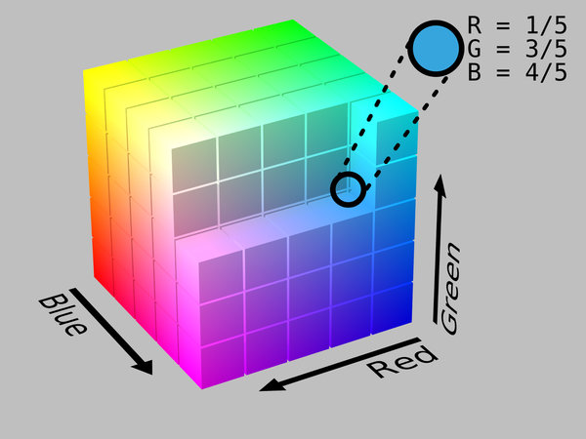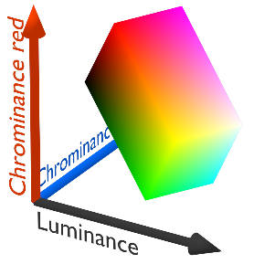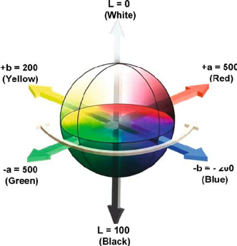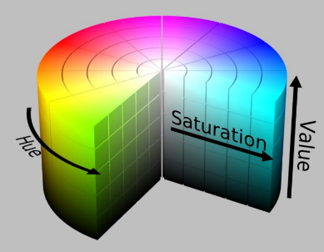

1. (b) (c) (d)

Figure 8. (a) RGB[7] (b) YCrCb[8] (c) LAB [9](d) HSV[10]

The initial conjecture was that HSV would be the best option. The ability to control color value with a single component in comparison to the other three, would be very beneficial to point out differences, regardless of the different shades of a picture.

To prove this, similar pictures at different levels of brightness were analyzed. The analysis consisted on comparing multiple mappable sections of the two similar pictures and evaluating how much effect the brightness had on the fluctuation of the color value. An example of the process with its respective tables (Table 1) can be seen in Figure 9. This example was run over multiple pairings of pictures with high and low brightness and all of them exhibited the same behavior. Early on, BGR color space was ruled out because it doesn’t divide the color components by brightness. Therefore, brightness influences how the color value is defined for a pixel. This can be a problem because weather conditions and the availability of sunlight can greatly affect the color value and thus, analyzing for drought response becomes harder, as brightness becomes a variable for the analysis.

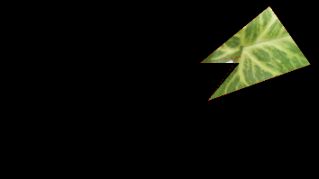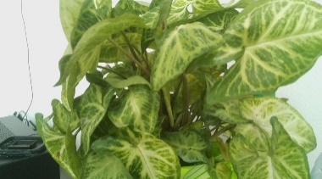

(a)

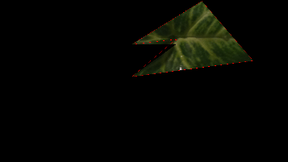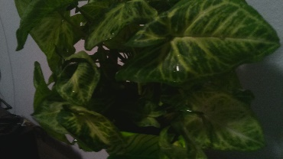

(b)

Figure 9. (a) High Brightness picture with its corresponding crop (Note that for each pair of pictures 5 sections were analyzed). (b) Low Brightness picture with corresponding crop.

Table 1.

|  |  |  |  |  |
| --- | --- | --- | --- | --- |
| HSV |  |  |  |  |
|  | Bright(H) | Dark(H) | Bright(H)-Stdev | Dark(B)-Stdev |
| 1 | 37.45 | 39.8 | 5.52 | 7.01 |
| 2 | 35.69 | 38.92 | 5.76 | 6.55 |
| 3 | 37.48 | 37.65 | 6.81 | 5.69 |
| 4 | 38.85 | 37.65 | 7.14 | 7.16 |
| 5 | 36.11 | 36.79 | 6.8 | 6.74 |

|  |  |  |  |  |  |  |  |  |
| --- | --- | --- | --- | --- | --- | --- | --- | --- |
| LAB |  |  |  |  |  |  |  |  |
|  | Bright(A) | Bright(B) | Bright(A)-Stdev | Bright(B)-Stdev | Dark(A) | Dark(B) | Dark(A)-Stdev | Dark(B)-Stdev |
| 1 | 108.67 | 168.3 | 12.81 | 5.93 | 118.39 | 147.87 | 11.63 | 8.87 |
| 2 | 110.22 | 171.06 | 14.74 | 5.85 | 117.78 | 150.87 | 14.11 | 8.56 |
| 3 | 107.81 | 172.01 | 17.91 | 7.14 | 120.42 | 145.12 | 11.39 | 7.26 |
| 4 | 110.5 | 164.35 | 16.98 | 7.49 | 119.68 | 149.3 | 14.29 | 9.05 |
| 5 | 111.15 | 169.56 | 16.94 | 7.25 | 119.18 | 152.09 | 15.89 | 8.3 |

|  |  |  |  |  |  |  |  |  |
| --- | --- | --- | --- | --- | --- | --- | --- | --- |
| YCB |  |  |  |  |  |  |  |  |
|  | Bright(Cr) | Bright(Cb) | Bright(Cr)-Stdev | Bright(Cb)-Stdev | Dark(Cr) | Dark(Cb) | Dark(Cr)-Stdev | Dark(Cb)-Stdev |
| 1 | 125.72 | 90.18 | 16.48 | 5.36 | 127.51 | 112.17 | 16.36 | 6.82 |
| 2 | 128.67 | 87.28 | 19.08 | 5.31 | 128.08 | 109.91 | 19.68 | 6.07 |
| 3 | 126.23 | 87.03 | 22.67 | 5.86 | 128.31 | 114.71 | 16.08 | 4.76 |
| 4 | 126.04 | 95.7 | 22.39 | 6.21 | 129.49 | 111.03 | 20.28 | 6.32 |
| 5 | 128.92 | 89.73 | 22.01 | 6.7 | 130.01 | 108.82 | 22.3 | 5.17 |

Note: This specific table is for the pair of pictures in Figure 9. The row corresponding to 1 corresponds the specific crop seen in Figure 9. The other 4 rows of values in each table is for a different mappable area in the pictures.

For the HSV table the mean value and standard deviation value of the Hue component is shown for each picture. In the LAB table, the mean and standard deviation for both the A and B components of the two different pictures are shown. Likewise, the same is done for the Cr and Cb components for the YCrCb color space for its respective table.

These values were specifically chosen because they represent the color value of the pixels in question. The tables show that the HSV space is the least affected by differences in the brightness of the picture. The Hue value changes by a small quantity between Bright and Dark pictures and its deviation is lower compared to most of the other color components of the other color spaces. Therefore, HSV was chosen as the color space to do visible light analysis.

*IR Analysis*

Thermal imaging can be beneficial for drought response analysis of plants. It can relate the surface temperature of the leaves with water availability. Planck’s radiation law states that every object above absolute zero emits electromagnetic radiation in the IR region. This is dependable on the emissivity of an object and its temperature[11].

Leaf and plant temperature is dependable on radiation, environmental conditions soil conditions, and canopy structure[12]. When submitted to stress, the temperature of a leaf increases [13] . If the temperature is lower than the temperature of the air the plant is assumed to be well watered. On the other hand, if the temperature exceeds the temperature of the air, then it is assumed that the plant is under drought stress. This relation is dependent on VPD, Vapor-pressure deficit, a value that quantifies the difference between moisture in the air and how much the air can hold when saturated[14]. With that in mind, there is a way to quantify drought stress. The problem comes in the calibration of thermal measurements. A thermal image will show different values depending on the radiation emitted. But to make sense of that data, it is important to calibrate said measurements. Said calibration can be achieved through the implementation of the CWSI (crop water stress index) [12]. This index is a measure of the transpiration rate occurring from a plant at the time of measurement and it is considered a quantification of drought stress. [15] implemented a variation of the index that can be easily reproducible for monitoring purposes. This approach involves including baseline points (a max transpiration area on the picture, which can be achieved by spraying a leaf with water and a minimum transpiration point that can be achieved by adding Vaseline) in order to map the response.

The analysis consisted in calibrating IR pictures taken at different points to establish if indeed it was possible to show drought response through IR analysis. An example of pictures taken can be seen in Figure 10. Even though the images show the different values of radiation, the calibration of the image intensity values was not successful enough to achieve the correct temperature values for the pixels. This was mainly due to fluctuation of environment variables. Proper quality control of the experiment as well as appropriate calibration strategies are needed for future experiments.

The process of calibration can be difficult if environmental conditions do not remain constant. To make sense of the information it is necessary to map a pixel value to a temperature value to determine the temperature scale. The first approach was to assume that the temperature given by the thermostat was the temperature of the air. The problem with this approach is that it leaves a lot of room for error as it assumes that most of the pixels that are not part of the plant are close to the thermostat value. This in conjunction with the low resolution of the picture , generates skew data. This was apparent as the image analysis gave inconsistent results when using the temperature of the thermostat as the mappable value.

Nevertheless, the data shows a relation between lower pixel values in the color scale in watered-plant pictures (as seen in Figure 10) and higher values in the color scale in dry-plant pictures. Without having a clear range of temperature values that can be mapped to the color scale used for the picture (Figure 10(c)), it is not possible yet to consider this as concrete proof that drought response can be seen using the IR camera. But given that the pictures were taken under similar environmental conditions it at least proves that there are differences between the images produced from well-watered plants and images produced by dry plants. This proves that indeed IR thermal analysis can be done using the equipment provided and that with better quality control, and accurate calibration, proof of dynamic IR monitoring can be acquired.

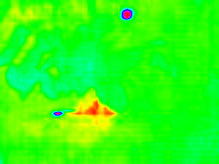

(a)

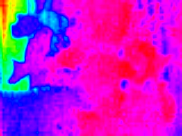

(b)



(c)

Figure 10. (a) Watered Plant with its respective colormap (b) Dry plant with respective colormap (c) Color scale

*VL Analysis*

VL analysis consisted in analyzing mappable areas of watered-plant pictures and dry-plant pictures. From these areas of interest, mean and standard deviation of the HSV components were calculated. As expressed before, color value is given by the Hue component. The Saturation vs. Hue plot in Figure 11 shows the relationship between the numerical value and a visible color. Given that the color of the leaves is green, the range of values expected when analyzing ranges from ~30 to ~80. To get the mappable areas, the same technique was used as when analyzing for ideal color space. An area of interest was cropped, and the mean and standard deviation values were calculated from this. Furthermore, values of the same mappable area were plotted to show the pattern of how the values changed throughout time (Figure 11).

(a)

(b)

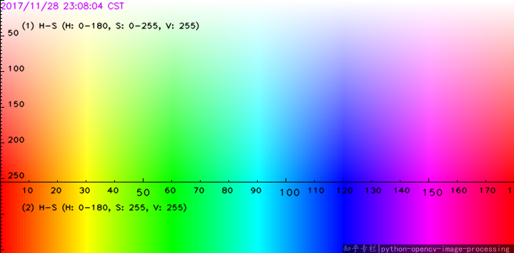

(c)

Figure 11. (a) Plot of the mean value of the mappable area of interest (b) Plot of standard deviation of mappable area of interest (c) Saturation vs. Hue plot with respective representation of color

The information in the plots is from pictures taken during a month period where a healthy plant was left to dry for two weeks and then was watered every 3-4 days for the rest of the month. The initial and midpoint pictures can be seen in Figure 12.

The plots show that as the plant became drier, the average hue value for the intended section decreased. Once the plant started to receive water again the value started to increase back to where it was when it was healthy. This proves that there is a relationship between the drought response of a plant and the Hue value of a picture. Furthermore, from the standard deviation plot and interesting analysis can be made. As the Hue value decreased so did the deviation, meaning that the area of interest becomes more compact in terms of color variation as the plant becomes drier. This makes sense, as when showing drought responses, the plant color value approaches the yellow hue(~30). This is a clear indication that the plant is drying out. The values taken will approximate 30 as the plant gets drier and thus there is going to be fewer variations of the green color present in the picture. On the other hand, the increased variation of the hue of a healthy plant also makes sense, due to the fact the maximum value (maximum mean in the data + maximum stdev) possible stays inside the green spectrum of the Hue component. This also means that there are different intensities of green colors in the healthy regions of the leaves.

The results provide the proof that indeed there exists analyzable differences between healthy and drought-stressed plants. It also proves that some of these differences can be highlighted through VL analysis.

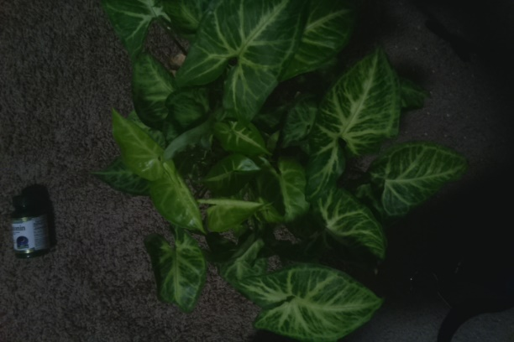 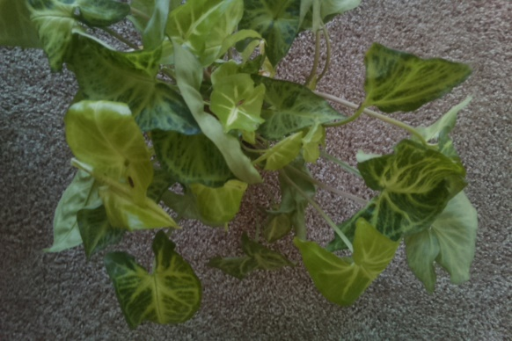

1. (b)

Figure 12. (a) Initial Picture(Healthy) (b) Midpoint picture(Dry)

**CPS**

To ensure that the CPS can provide remote monitoring applications, it is important to make sure that it is able to deliver images through the network and that it can take pictures remotely.

For remote delivering, both the Pi Zero and Pi3 were tested. It was important that both were able to connect to the network and transfer files through it. Both devices provided network capabilities from the start, so this was a very straightforward.

The second task was solved by establishing a point of reference for the system to look for that would tell it that it was the right time to take the picture. Given that in the real-world setting the robot would be moving, this point of reference would also tell it to stop. For the experiment, a piece of colored paper was used as a reference. This can be seen in Figure 4.

Using the camera feed, the system would take the picture when the camera feed found enough values of this reference point (in the case of Figure 4 the yellow color) at certain (x,y) positions of the picture. If enough values were found, the camera was calibrated, and both the VL and IR pictures were taken.

Figure 4 illustrates that indeed usable pictures can be taken through this method. Also, given that the script used for taking the pictures, takes in input for the x and y range of positions to look for the marker, this is a method that can be implemented under the conditions that the experimenter wants, allowing for customization of the picture taking process.

Chapter IV

Conclusion

A CPS that can actively monitor plants and deliver VL and IR images through the network is indeed possible to develop. This system is also adaptable to different image-taking related experiments.

VL analysis using the HSV color space can be used to map drought related differences in plants, and thus drought related responses are identifiable through this process.

Even though there is no concrete proof that drought related responses are identifiable using IR analysis, there is enough proof to show that IR analysis shows difference between dry and watered plants. Under controlled conditions and effective implementation of thermal calibration, IR analysis can potentially be utilized to map drought related responses in plants.

Furthermore, this system can provide flexibility in drought stress related experiments. With the ability to actively monitor plants, the next step is to generate a prediction model of drought related responses that will help for the analysis of future data.

References

[1] “kinetic/Installation/Debian - ROS Wiki.” [Online]. Available: http://wiki.ros.org/action/fullsearch/kinetic/Installation/Debian?action=fullsearch&context=180&value=linkto%3A%22kinetic%2FInstallation%2FDebian%22. [Accessed: 09-Apr-2018].

[2] “About - OpenCV library.” [Online]. Available: https://opencv.org/about.html. [Accessed: 09-Apr-2018].

[3] M. O. Balaban, A. Z. Odabaşi, S. Damar, and A. C. M. Oliveira, “8 - Quality Evaluation of Seafood,” in *Computer Vision Technology for Food Quality Evaluation*, D.-W. Sun, Ed. Amsterdam: Academic Press, 2008, pp. 189–209.

[4] “YCbCr Definition from PC Magazine Encyclopedia.” [Online]. Available: https://www.pcmag.com/encyclopedia/term/55147/ycbcr. [Accessed: 09-Apr-2018].

[5] “Lab color space - an overview | ScienceDirect Topics.” [Online]. Available: https://www.sciencedirect.com/topics/agricultural-and-biological-sciences/lab-color-space. [Accessed: 09-Apr-2018].

[6] J. H. Bear, “Understanding the HSV Color Model,” *Lifewire*. [Online]. Available: https://www.lifewire.com/what-is-hsv-in-design-1078068. [Accessed: 09-Apr-2018].

[7] “RGB color space,” *Wikipedia*. 06-Apr-2018.

[8] “Talk:YCbCr,” *Wikipedia*. 07-Jan-2017.

[9] “The cubical CIE Lab color space  | Research Diagram.” [Online]. Available: https://www.researchgate.net/figure/The-cubical-CIE-Lab-color-space_fig3_23789543. [Accessed: 09-Apr-2018].

[10] “HSV Color Space.” [Online]. Available: https://www.researchgate.net/figure/HSV-Color-Space_fig2_284488273. [Accessed: 09-Apr-2018].

[11] J. M. Costa, O. M. Grant, and M. M. Chaves, “Thermography to explore plant–environment interactions,” *J Exp Bot*, vol. 64, no. 13, pp. 3937–3949, Oct. 2013.

[12] W. H. Maes and K. Steppe, “Estimating evapotranspiration and drought stress with ground-based thermal remote sensing in agriculture: a review,” *J Exp Bot*, vol. 63, no. 13, pp. 4671–4712, Aug. 2012.

[13] “Wheat canopy temperature: A practical tool for evaluating water requirements - Jackson - 1977 - Water Resources Research - Wiley Online Library.” [Online]. Available: https://agupubs.onlinelibrary.wiley.com/doi/pdf/10.1029/WR013i003p00651. [Accessed: 09-Apr-2018].

[14] “Canopy temperature as a crop water stress indicator - Jackson - 1981 - Water Resources Research - Wiley Online Library.” [Online]. Available: https://agupubs.onlinelibrary.wiley.com/doi/pdf/10.1029/WR017i004p01133. [Accessed: 09-Apr-2018].

[15] H. G. Jones, “Use of thermography for quantitative studies of spatial and temporal variation of stomatal conductance over leaf surfaces,” *Plant, Cell and Environment*, vol. 22, no. 9, pp. 1043–1055, Sep. 1999.

[16] “Luminance | Define Luminance at Dictionary.com.” [Online]. Available: http://www.dictionary.com/browse/luminance. [Accessed: 09-Apr-2018].

[17] “Chroma | Define Chroma at Dictionary.com.” [Online]. Available: http://www.dictionary.com/browse/chroma. [Accessed: 09-Apr-2018].

Appendix

M

**middleware:** software present between an OS and an application used for communication and resource allocation purposes

O

**operating system:** program that manages all processes and resources in a computer

S

**source installation:** highly customizable method of installing software where the user builds the source code, takes care of dependencies and can select special features not available when installing binary packages

L

**luminance**: intensity of light emitted from a surface[16]

C

**Chroma:** purity or intensity of a color[17]